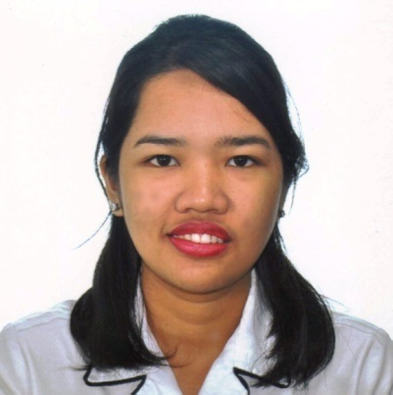

SUSSIE B. ACEDERA

 201 Alserkal Building Al Rigga Deria, Dubai.

Mobile No: 0544033923

Email add: sussie.acedera@yahoo.com

OBJECTIVES: To obtain a full time position in a well established organization which offers a professional environment and enables me to achieve career opportunities by utilizing my knowledge and skills that will contribute in meeting the corporate and personal goals.

EDUCATION:

- Tertiary University of the East
BSBA Major in Management Accounting
2219C.M Recto Avenue Manila SY 2007 - 2011

AREAS OF EXPERIENCE:

→ Service/Sales Associate EASTWEST BANK CORPORATION
Relieving Pool Department, Division 7
138 Kamias St. Quezon City Philippines
Oct 24, 2011 – Jan 31, 2012
332-5127

→ Transaction Processing Associate ACCENTURE PHILIPPINES
Accounts Receivable & Global Revenue Operation Department
7th floor Robinsons Cybergate 1 Pioneer Street
Mandaluyong City, Metro Manila 1554
Feb 13, 2012 – May 6, 21016
580-5888/268-1000

SEMINARS AND TRAININGS:

→ The Relevance of Financial Management to the Corporate Setting
Technological Institute of the Philippines
- rora Blvd., Cubao, 1113 Quezon City
September 13, 2011

- Writing with Precision
6th Flr, Gateway Tower 1, Cubao Aurora Quezon City
September 2012

- The Bigger Picture
8th Flr, Gateway Tower 1, Cubao Aurora Quezon City
May 2012

SKILLS AND INTERESTS:
Time Management skills; flexible and dependable
Interpersonal communication skills
Cash handling skills
Customer service skills

ELIGIBILITY:
®MS Word, Excel, PowerPoint
®System Applications and Products (S.A.P.)-Business Process and Integration Software
®MS Access
- Oracle

AFFILIATION:
®Junior Institute of Management Accounting
Technological Institute of the Philippines Quezon City
Year 2008-2010

PERSONAL INFORMATION:

Nickname: Sue
Date of Birth: June 23, 1991
Place of Birth: Quezon City
Age: 25
Height: 5’4.
Religion: Catholic
Nationality: Filipino
Language Spoken: Tagalog, English

